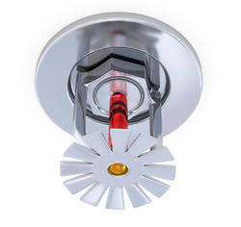

PENNSYLVANIA FIRE SPRINKLER INFORMATION GUIDE

Philadelphia Focus Edition

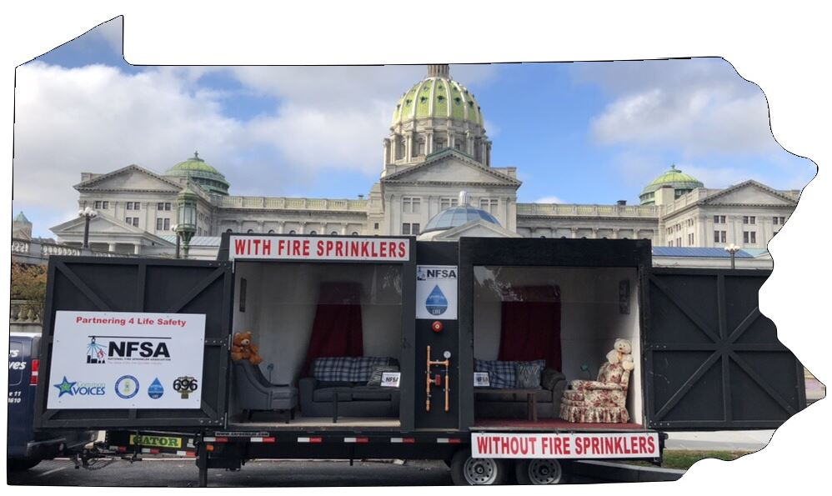

Fire Sprinklers Save Lives!

pENNSYLVANia fire fatalities:

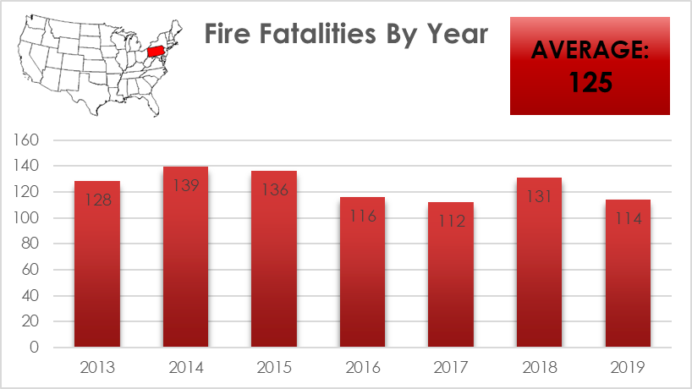

According to the United States Fire Administration (USFA), between January 1, 2013 and December 31, 2019 an average of 125 Pennsylvanians died each year in residential fires.

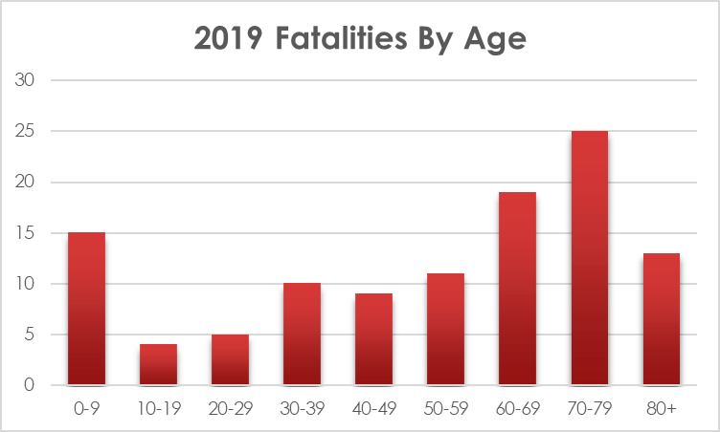
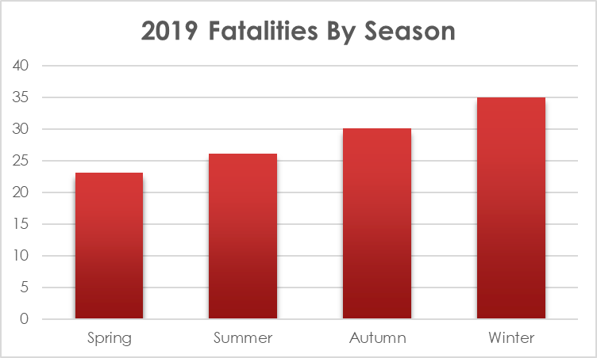
PENNSYLVANIA FIRE FATALITIES:

fire fatalities

The United States Fire Administration (USFA) reported 114 civilian residential fire fatalities across the State of Pennsylvania in 2019. 32 of those deaths occurred in Philadelphia (28%).

2019: 32*

*AS OF 11/13/2019

2018: 19

2017: 20

2016: 21

KNOW THE RISK
According to the Connecticut-based insurer, The Hartford, Philadelphia is ranked 13th among the 100 U.S. cities with the highest home fire risk.

WHY ARE FIRE SPRINKLERS NECESSARY IN HOMES?
Modern homes are built using lightweight construction and are filled with furnishings made of synthetic materials. Lightweight construction and synthetic furnishings burn hotter and faster today.
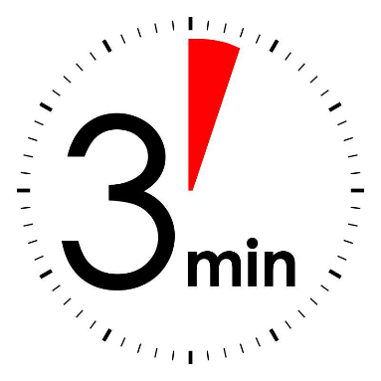
Modern homes burn 8 times, 800%, FASTER than older homes. You may only have 3 minutes after the smoke alarm goes off to get your family out safely!

Approximately 3,000 people die in fires in America every year. 80% of fire deaths occur in single family homes.
One home fire is reported every 85 seconds.
One person is injured in a fire every 33 minutes.
One person dies in a fire every 162 minutes.
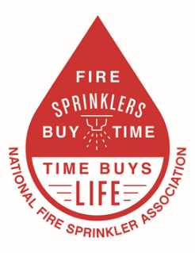
Residential fire sprinklers reduce the chance of death in a fire by over 80%.
Home fires resulted in $9.5 billion in property damage in 2013

WHY DO FIRE SPRINKLERS NEED TO BE REQUIRED?
- Residential Fire Sprinklers are already required by code. The current International Residential Code requires all single-family homes to be equipped with residential fire sprinklers.
- The estimated cost to the builder to install a residential fire sprinkler system in Philadelphia is approximately $2.00 per square foot. This is often less than the cost of upgraded granite counter tops.
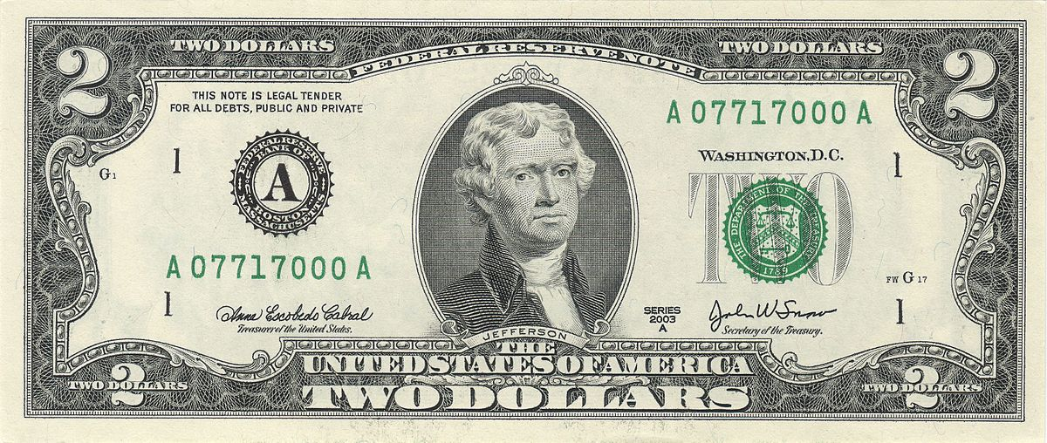

- Many municipalities offer homebuilders incentives to install sprinklers, such as allowing more residential units, longer dead ends, reduced street width, increased hydrant spacing and many other benefits that save money and increase builder profits.
- Fire sprinklers can provide protection to the approximately 3,000 people, mainly children, elderly and disabled, who die each year in residential fires throughout the United States!

WHAT ARE THE COST BENEFITS OF FIRE SPRINKLERS?
- In homes with fire sprinklers, the average property loss is cut by nearly 70% compared to a home without sprinklers.
- It was reported that homes with fire sprinklers report an average property loss of $2,166 after a fire compared to more than $45,000 in an unsprinklered home.
- Nationwide average cost for a residential fire sprinkler system is 1-1.5% of the total home construction cost.
- Often as an incentive for customers, insurance companies offer discounts ranging from 5% to 25% off the fire portion of homeowner premiums.
- Can you put a price on peace of mind?

HOW DO FIRE SPRINKLERS WORK?
- Fire sprinklers are activated by heat. Smoke will not activate a fire sprinkler.
- Only the sprinkler head activated by the heat will discharge. Water from the sprinkler contains or extinguishes the fire.
- In 90% of structure fires, only one or two sprinkler heads activate, protecting surrounding rooms from fire, heat, smoke and often water damage.
- The average sprinkler discharges 15 – 26 gallons of water per minute, compared to 150 – 250 gallons per minute by just one fire hose. If it takes approximately five minutes to extinguish a house fire by the fire department, over 1,000 gallons of water would be used by the fire department versus only 130 gallons from a fire sprinkler for the same amount of time.
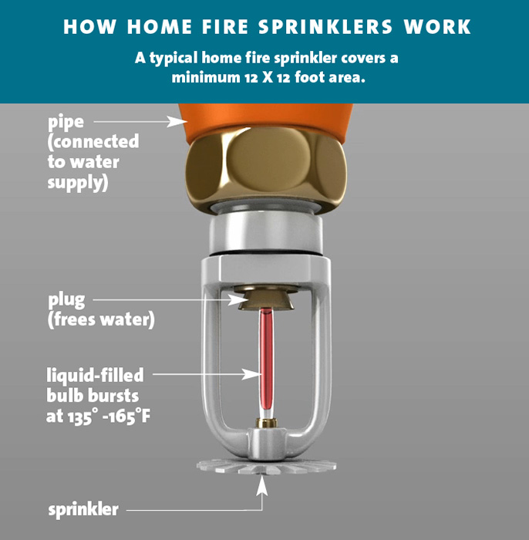

WHY IS INSPECTION, TESTING, & MAINTENANCE (ITM) IMPORTANT?
Having an effective program of inspection, testing, and maintenance (ITM) is one of the most important measures you can take to assure the success of the fire sprinkler system.

Its purpose of ITM is to discover and mitigate potential failures of critical components that would prevent the fire sprinkler system from operating properly in the event of a fire before a fire occurs.

By identifying potential problems, proper ITM procedures can help eliminate the two most common causes of unsatisfactory fire sprinkler performance:
Closed valve(s) in the water supply line.

The delivery of an inadequate water supply to the fire sprinkler system.

A fire sprinkler system that is regularly tested, inspected, and properly maintained can effectively protect a building from the threat of fire for the entire life of that building.
The PenJerDel Chapter of NFSA

The PenJerDel Chapter of the National Fire Sprinkler Association is a group of professionals whose shared interest is advocating for the widespread acceptance and implementation of fire sprinklers. Members come from a variety of different fields, from fire services to education and marketing, but they all share a common goal: to save lives and protect property. In accordance with its mission, the PenJerDel chapter is committed to promoting the fire sprinkler industry, protecting the fire sprinkler industry, and strengthening the National Fire Sprinkler Association.

The PenJerDel Chapter works closely with members of local communities, including firefighters, educators, and elected officials, to accomplish this goal.

The Chapter offers several educational events that highlight fire sprinkler effectiveness, including burn trailer demonstrations, side-by-side burns, grant burns, and training seminars.

David Kurasz
Executive Director
NFSA - PenJerDel
kurasz@NFSA.org

Frank Ellis
State Coordinator
NFSA - PenJerDel
ellis@NFSA.org
NFSA - PenJerDel
127 Route 206, Suite 11
Hamilton, NJ 08610
866.226.6006

