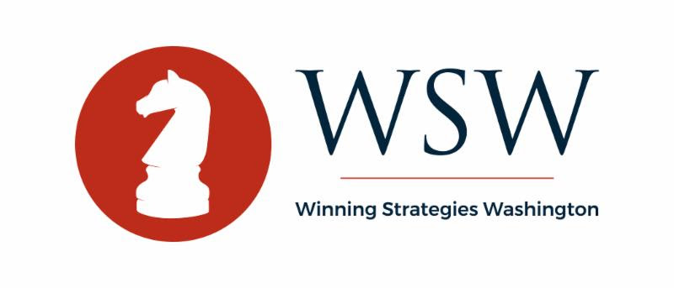

Winning Strategies Washington Report - May 29, 2020

100,000. Even as deaths from COVID-19 in the U.S. reached 100,000 this week, the focus in Washington has shifted significantly to the reopening of the economy. The White House COVID-19 Task Force is reportedly winding down, and even in Congress, attention has shifted to discussions around economic recovery packages - including the possibility of a major infrastructure initiative. That said, as more and more states move through their phased reopening plans, there is also significant attention being paid to both the health and economic impacts, including the rollout of test and tracing capacities, as well as close attention on plans for reopening schools and universities in the fall.

Please, I can't breathe. The tragic death of George Floyd in Minneapolis has drawn significant national attention, including by President Trump and Democrat Presidential nominee Joe Biden, as well as condemnation by a broad array of organizations including major law enforcement organizations. Expect renewed focus - both political and policy - in Washington on racial discrimination.

Fixing the Paycheck Protection Program (PPP). The House was back in Washington this week and working to modify the PPP program to add both clarity and flexibility for this critical program aimed at assisting small businesses through this crisis. On Thursday, the House passed H.R. 7010, the Paycheck Protection Program Flexibility Act, by a vote of 417-1. More information on the package is available here. Key PPP changes in H.R. 7010 include:
- allowing forgiveness for expenses for up to 24 weeks, and extending the rehiring deadline;
- increasing the current limitation on nonpayroll expenses (such as rent, utility payments and mortgage interest) for loan forgiveness from 25 to 40 percent;
- extending the program from June 30 to December 31;
- extending loan terms from two to five years; and
- ensuring full access to payroll tax deferment for businesses that take PPP loans.
The bill now moves to the Senate, which has been working on a more narrow approach to addressing concerns with the PPP. The Senate bill - S. 3833, the Paycheck Protection Program Extension Act - would extend the loan use period from 8 weeks to 16 weeks, and extend the program expiration date from June 30, 2020 to December 31, 2020; it does not address the 75/25 requirement or 2-year loan term.

Before any PPP changes go into effect, the differences will need to be reconciled and the legislation will have to pass both the House and Senate, and be signed into law by the President. At this point, it's unclear how the Senate will proceed, but pressure is building for quick action, so we expect more developments in the coming days.

Historic First, Remote Voting in the House. The House took the historic step this week of allowing optional remote voting. 70 Members invoked their proxy, meaning another Member that was present on the House Floor was able to vote on their behalf and in consultation of the absent Member. The move was not without controversy as House Republicans filed a lawsuit Tuesday declaring remote voting is unconstitutional.

National Defense Authorization Act (NDAA). The Senate Armed Services Committee this week announced the markup schedule for the FY2021 National Defense Authorization Act (NDAA) bill, with subcommittee markups and full committee markup expected between June 8-11. The House Armed Services Committee's NDAA markup has not yet been announced, but some reports indicate subcommittee markups will occur before the end of June. The NDAA will be one of the first non-coronavirus related bill to start moving through the Committee process since early March.

Next COVID-19 and Economic Recovery Package. Congressional Leaders on both sides of the Capitol acknowledged another "Phase Four" Coronavirus package is needed - at some point.

Senate Majority Leader McConnell continues to insist on inclusion of liability protections. In recent days, some rank and file Democrats have stated that a limited set of liability protections may be warranted to aid the phased reopening and protect both industry and other entities such as Universities that follow public health regulations and guidelines. In addition, more than 200 trade groups representing much of corporate America are urging Congress to act, stating in a letter to Congress this week, "Absent a targeted safe harbor for those that work to follow applicable guidelines, the fear and uncertainty from boundless liability threatens to impede our country's social and economic recovery."

Speaker Pelosi (CA) and Minority Leader Chuck Schumer continue to push the $3 trillion HEROES Act, which has already passed the House and includes more direct aid to individuals, families, and front-line workers, significant relief for state and local aid and more funding for testing and tracing. TIMING of the next package remains unknown.

House Schedule. On Friday, the House released an updated calendar for the remainder of 2020. Notably, the House is not scheduled to vote again until the end of June, with the rest of the month listed as "committee work days." The August recess remains as scheduled, with the House aiming to return to a more normal schedule after Labor Day.

WSW Coronavirus Information Library
Below are links to our updated Special Reports, which captures all of this last week's key developments in each area.

Counties and Municipalities
Health Care
Higher Education
Non-Profit
Small Businesses

